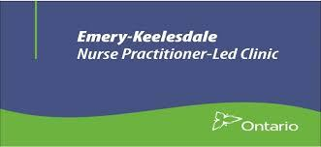

Board Member – Volunteer Position
Emery-Keelesdale Nurse Practitioner-Led Clinic (EKNPLC) provides and coordinates services that connect both health care services and services from other sectors to address the broader social determinants of health as they affect the most vulnerable residents of the clinic’s catchment. We envision a vibrant, ongoing and meaningful collaboration between various health and non-health sectors creating a healthier and more equitable North York West community.
We are seeking three (3) candidates to join our Board of Directors, which is responsible for governance and provides strategic leadership. Directors are volunteers who serve without remuneration. They are elected for a three-year term and must attend regular Board meetings (typically 10 meetings annually), and sit on one Board committee. The monthly time commitment averages 4 to 6 hours.
While board experience is desirable, we are looking for individuals who bring at least one (1) of these specific skills and experiences:
- Nurse Practitioner
- Business Experience
- Finance/Accounting
- IT/Social Media
- Board Governance
Members of the Board will interview selected applicants during the months of November and December 2020. Successful candidates will be asked to attend Board meetings, starting in January 2021.
EKNPLC is committed to creating equal opportunities for all and to building a Board that reflects the diversity of our clients and the community. We encourage individuals from equity-seeking groups and diverse backgrounds to apply.
Please send your resume to: board@eknplc.ca
Attention: Board Chair Amin Remtulla
We appreciate the interest of all candidates. However, only those selected to meet with representatives of the Board will be contacted.

